Karabar Distance
Education Centre

elearning @
Finigan School of
Distance Education

Karabar Distance Education Centre
Phone: 02 6210 5200
Email: karabar-d.school@det.nsw.edu.au
www.karabardec.com.au

Welcome to e-learning @ Finigan

Welcome to electronic learning (e-learning) at Karabar Distance Education Centre. Most of your courses are presented electronically in MOODLE – a web based learning management system. You will complete all your work, except for examinations and some assessment tasks, by accessing this site.

Information for Students

The essential method for the school to contact you will be via your education account. It will also be the primary identification for other areas within distance education.
Moodle is a Course Management System used at Finigan School of Distance Education to create on-line courses. Moodle allows students to access courses via the Internet – anywhere, anytime.
Students are able to:
- download resources and activities
- complete quizzes
- participate in forums and wikis
- access podcasts
- view video and audio files
- Upload completed files
- message / email their teachers
Another very useful feature of Moodle is that of submitting work electronically. Weekly work files can be uploaded for teacher assessment all within the Moodle system. Teachers then correct work and return marked work via Moodle.

Accessing Moodle

Access the website for course work - Moodle

Click Log In (Top right)
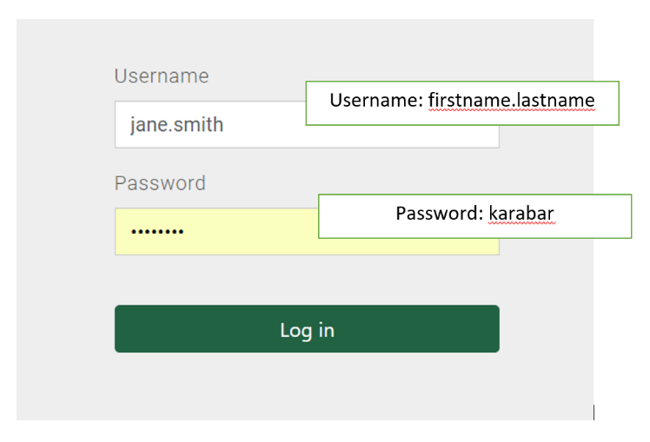

distance

Enter your username (firstname.lastname)
Initial Password: distance
You will be prompted to change your password after the first login.
Enter the current password (distance)
Enter the password you would like to use.
If your username and password does not work, please contact Technology Support.

Resetting your password
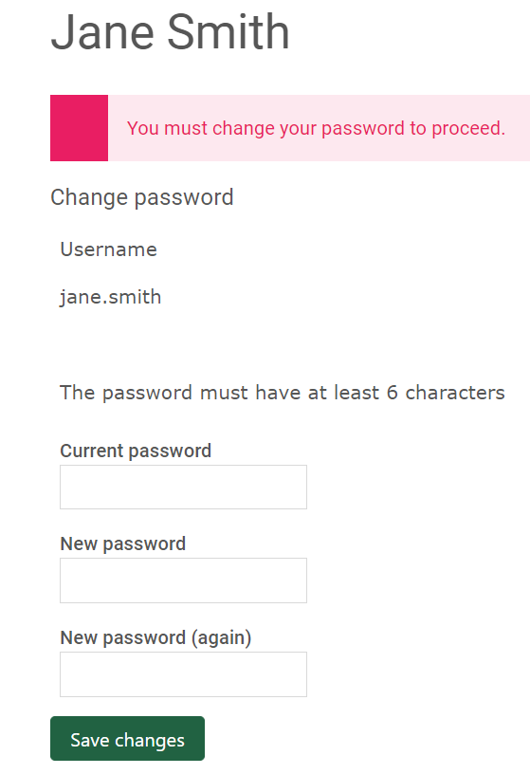
Click continue.
On the top, right go to My Courses
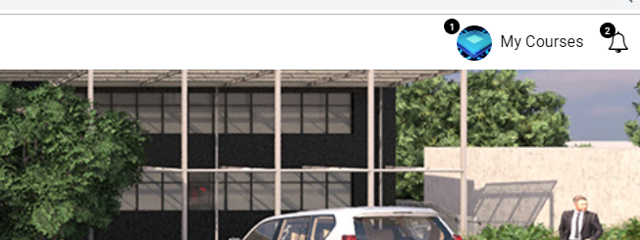
You will see a link to all your courses.
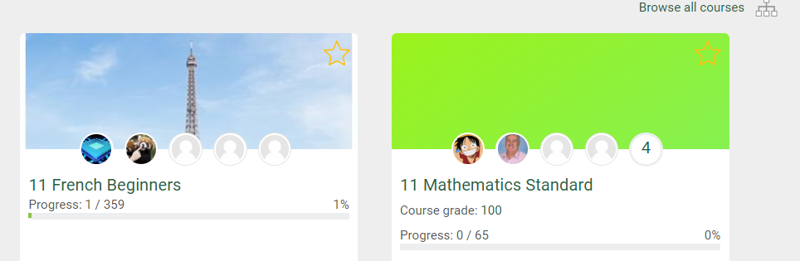

Click on the image to access your course page.

Example Course Page
Topic name as on planner
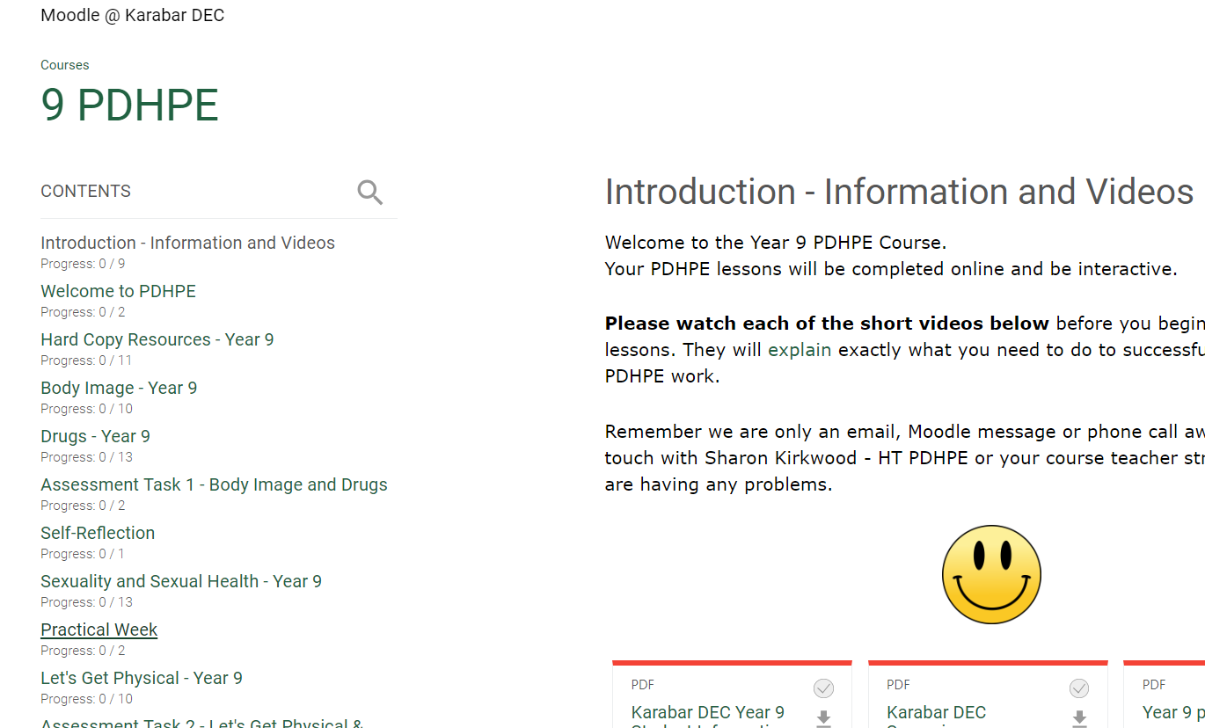

Using your student planner as a guide to navigate to the relevant topic to your lessons and complete the lessons and activities provided.
Example activities
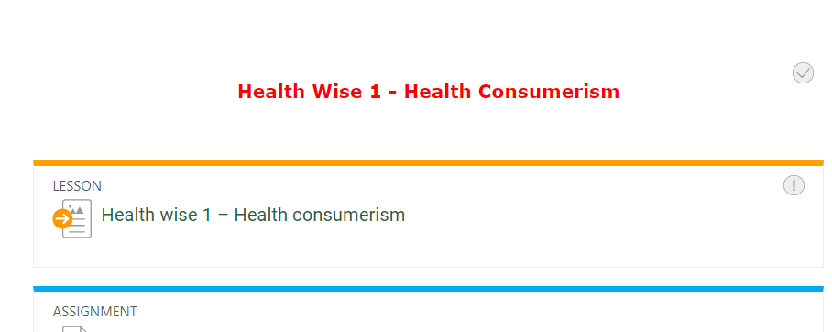

Uploading your completed files to the Drop Bins for marking

You will see an area to upload completed work each week.
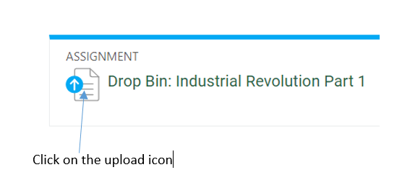
Click on Add submission.

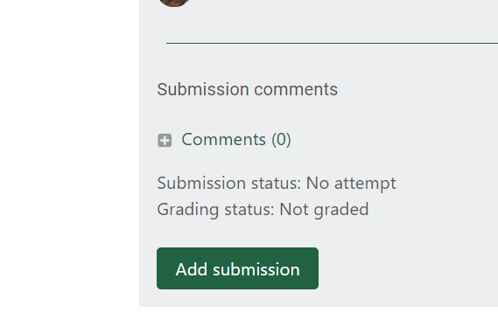
Click on the 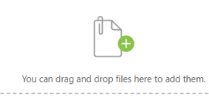 icon and navigate to the folder on your computer where the file is saved.
When the file is uploaded Save changes. A notification will be sent to your teacher to let them know you have submitted the file/s.
Note: It may be possible for you to use the Moodle Mobile app if you have connection issues contact Technology support on 6210 5200 for assistance.

Information for Supervisors

- Student Planner
Locate and refer to the planner (a supervisor’s copy was posted out with the initial pack). A sample planner for Year 7 follows. The planner topics will be different for Years 7, 8, 9, 10 and 11.

Sample Student Planner

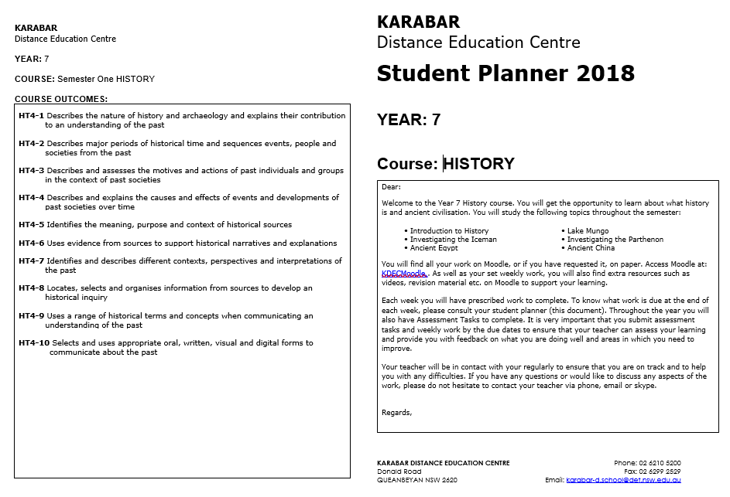

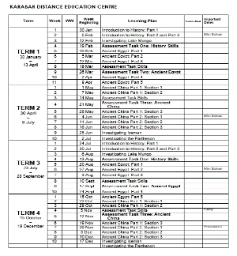
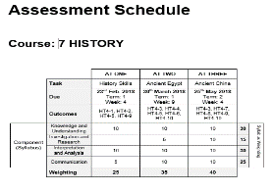

The planner outlines the work that needs to be completed each week of the school term. The date for the commencement of each week is given to help timetable the work. The Assessment Tasks are also scheduled on the planner.
As your student completes each week’s work (usually on a Friday), check the send in exercises and then tick off the work on your copy of the planner.

- How to organise the students school work

  - Set folders on the students computer.
  - Create a folder – for example ‘Science’ English’ ‘PDHPE’
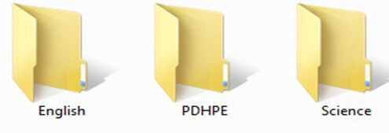
Set up labelled folders within each course folder
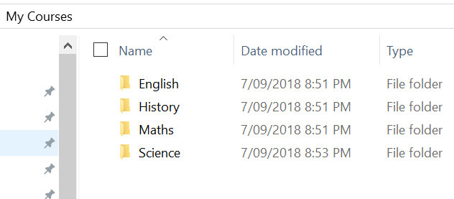
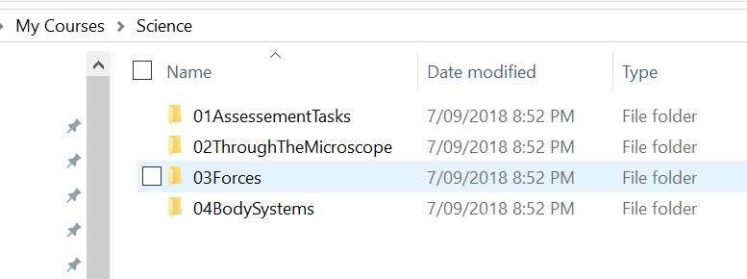

Save the Send-in-exercises into the relevant folder.
Completed work can then be submitted to the Dropbin in Moodle. Any handwritten work can be scanned (Cam Scanner phone app) or photgraphed then uploaded to the Dropbin in Moodle.

Checking student work before it is uploaded to Moodle

At the end of the week your role as supervisor is to view the relevant file(s) (send in exercises) on your student’s computer. ONLY the send in exercises are returned to the teacher, not the lesson work.

EITHER
Ask the student to email you the completed file

OR
Ask the student to open the file and show you the completed work for this week on their computer.

Your role is to quickly check that the exercises have been attempted. The teacher’s role is to correct and provide feedback on the work.

The file will be marked by the teacher and then uploaded back to Moodle. The student can then show you the teacher’s feedback.

Further help files such as are available on the front page of the Moodle site
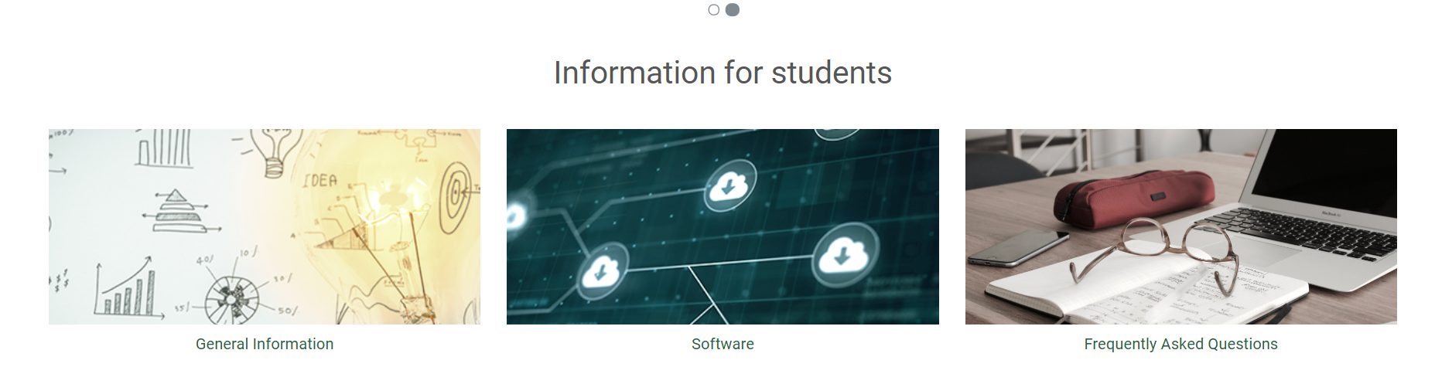
- Any required software can be downloaded for free. Students will need their school email address to access free software such as Microsoft Office and Adobe Creative Cloud.
- Detailed instructions on how to access the free software and school emaill account can be found on the front page of the Moodle site.
- Supervisiors are also given access to the school portal. This will provide information on student feedback from each weeks work, assessment tasks and school reports.
- An email will be sent to supervisors upon enrolment with all login details.

Assessment Tasks

Assessment Tasks have been set for the student to complete throughout the year.
Some Assessment Tasks are in Moodle. Each task has a specified due date (on the program and the Assessment schedule).
Examinations will be posted in hard copy.

Please contact the relevant faculty with any questions or problems.

Contact Information and Links

NSW only (local call charge) | 1300 360 384
Administration | (02) 6210 5200
Technology and/or  Moodle help | (02) 6210 5200

Links:
Email address: | finiganSDE@det.nsw.edu.au
Website: | https://finigan-d.schools.nsw.gov.au
Moodle: | Go to the e-learning link on the website
Student portal for email | https://student.det.nsw.edu.au
School Portal (for feedback and reports): | https://de.millenniumschools.net.au/portal/
Free software | https://nsw-students.onthehub.com/WebStore/Welcome.aspx?JSEnabled=1

